Quantum in VET: Cooking, Homes,Beauty
This lesson plan represents the practical implementation of the knowledge and strategies acquired during the “Karriere Quantum Camp” held in London, July 2025.
The ideas developed throughout the camp have been adapted to fit the vocational education context, enabling students to explore how quantum technologies may transform their future professions.

Target Group: Vocational students (Cooks, Home Installations, Hairdressing)
Time: 45–90 minutes
Mode: Face-to-face / Hybrid
Main Theme: How quantum technology will change everyday jobs
Learning Objectives
By the end of the lesson, students will:
- Understand and use job-specific vocabulary connected to quantum technology.
- Improve reading comprehension through simple, future-oriented texts.
- Complete matching and fill-in-the-blank tasks to reinforce vocabulary.
- Engage in creative and critical thinking by researching and imagining quantum devices for their profession.
Student “Can do” statements
By the end of this lesson, I can:
- talk about how technology might change my future job,
- understand and use new job-related words,
- imagine and describe a quantum device for my profession.

Warm-up (10 min)
Goal: Build background knowledge and interest.
Step 1 – Visual Hook (2 min)
Show 3 pictures or short videos (can be on slides or printed):

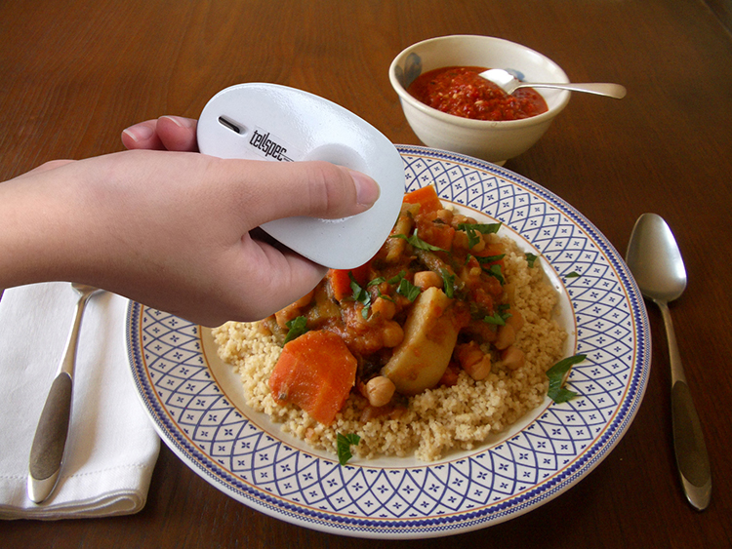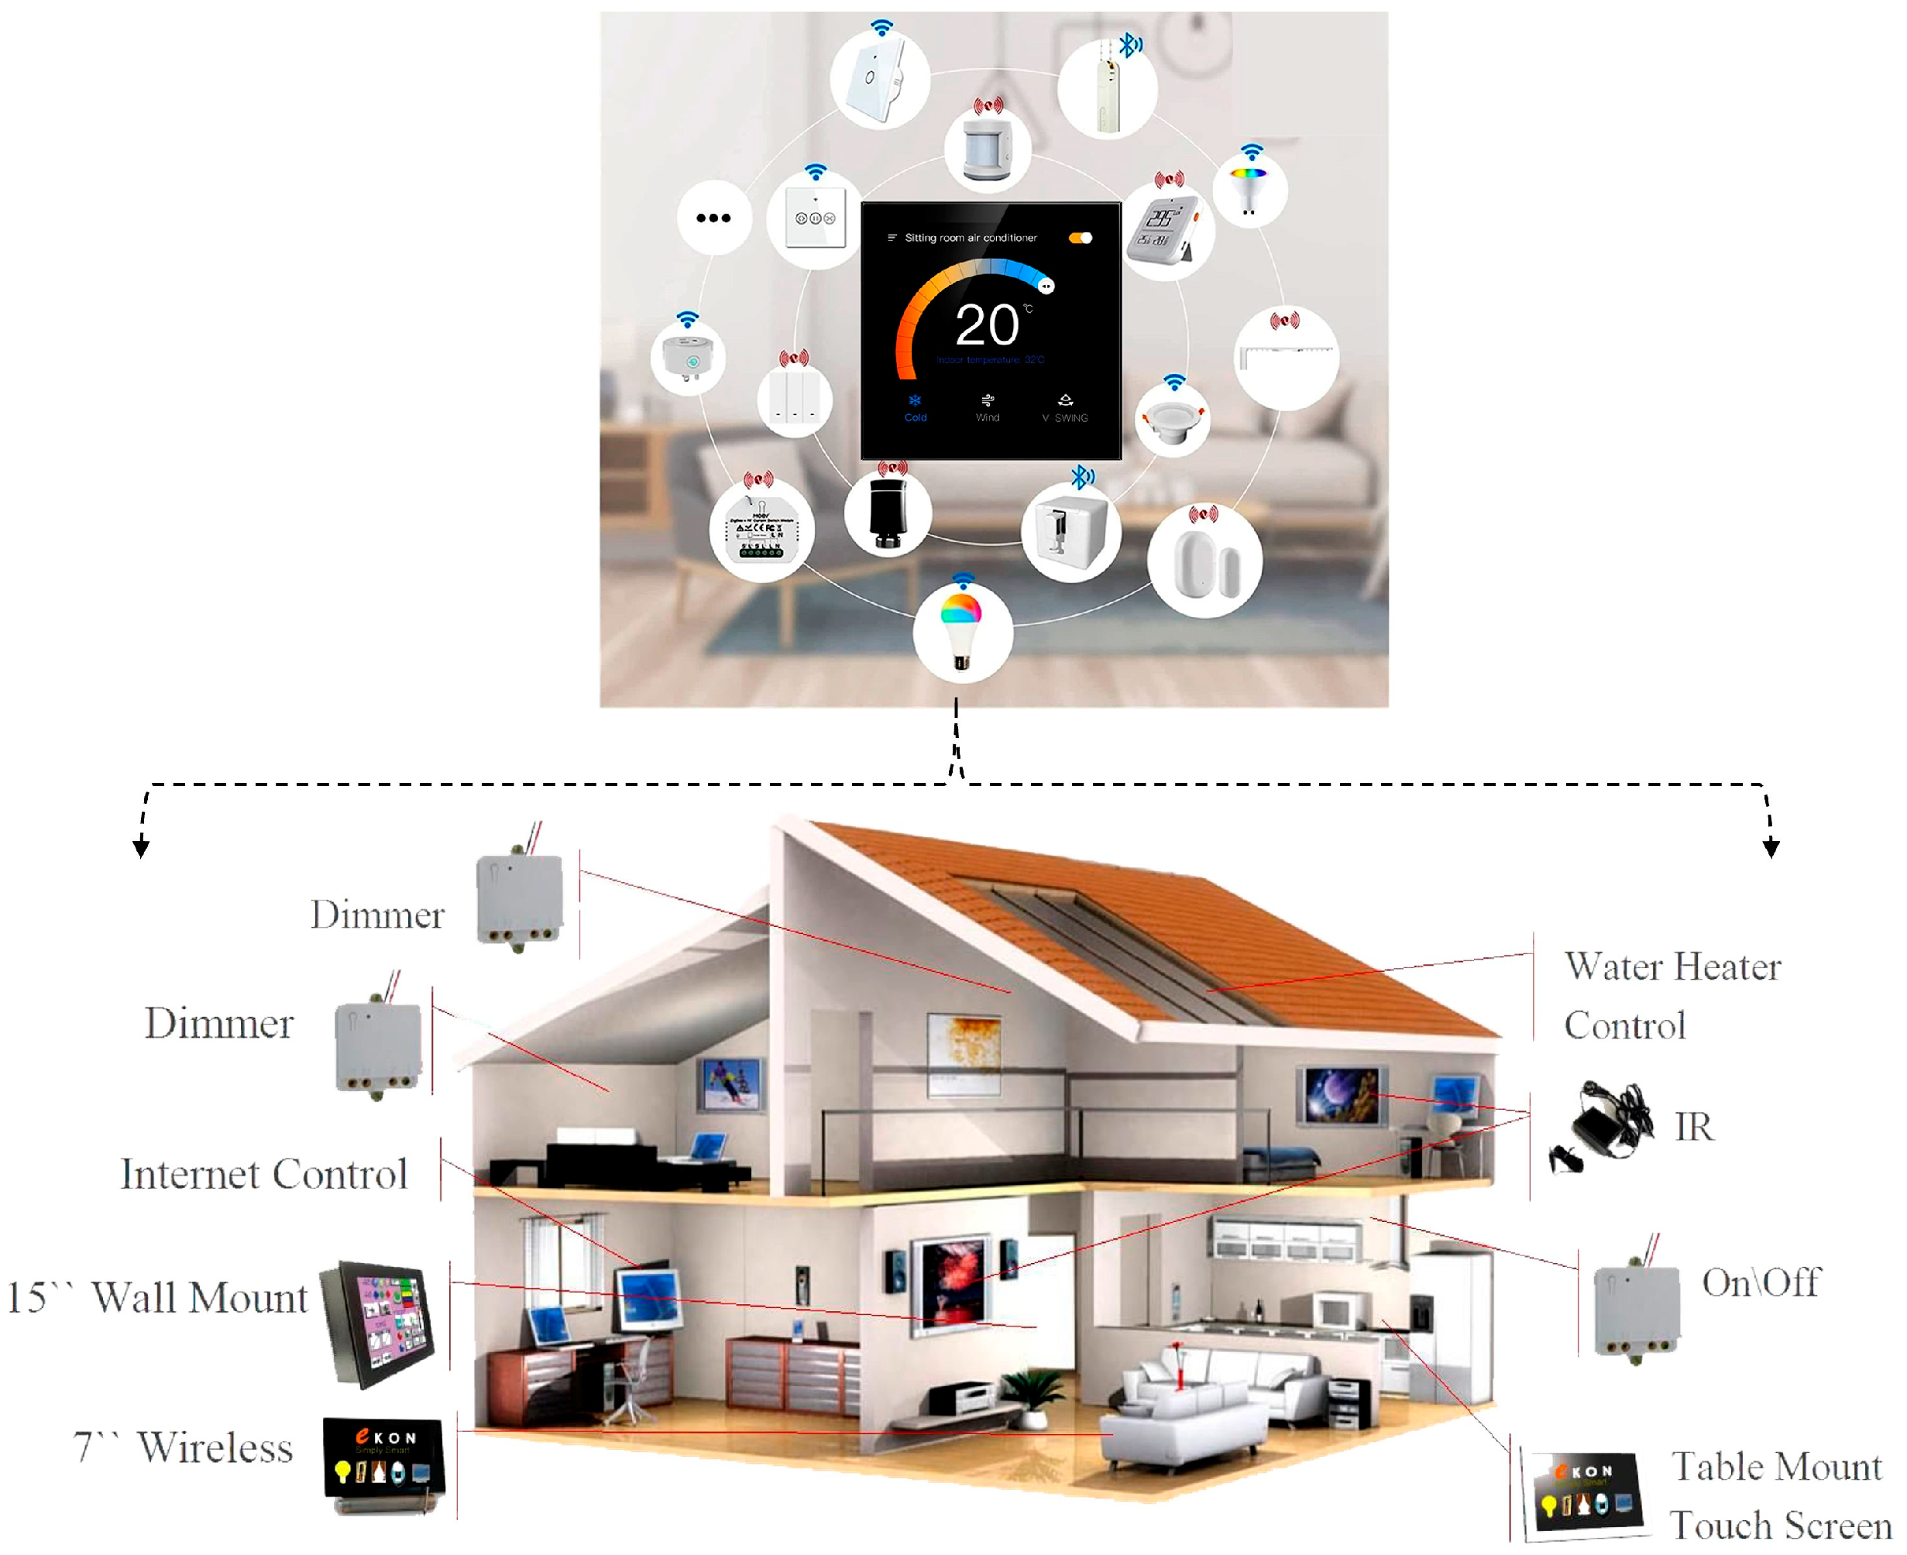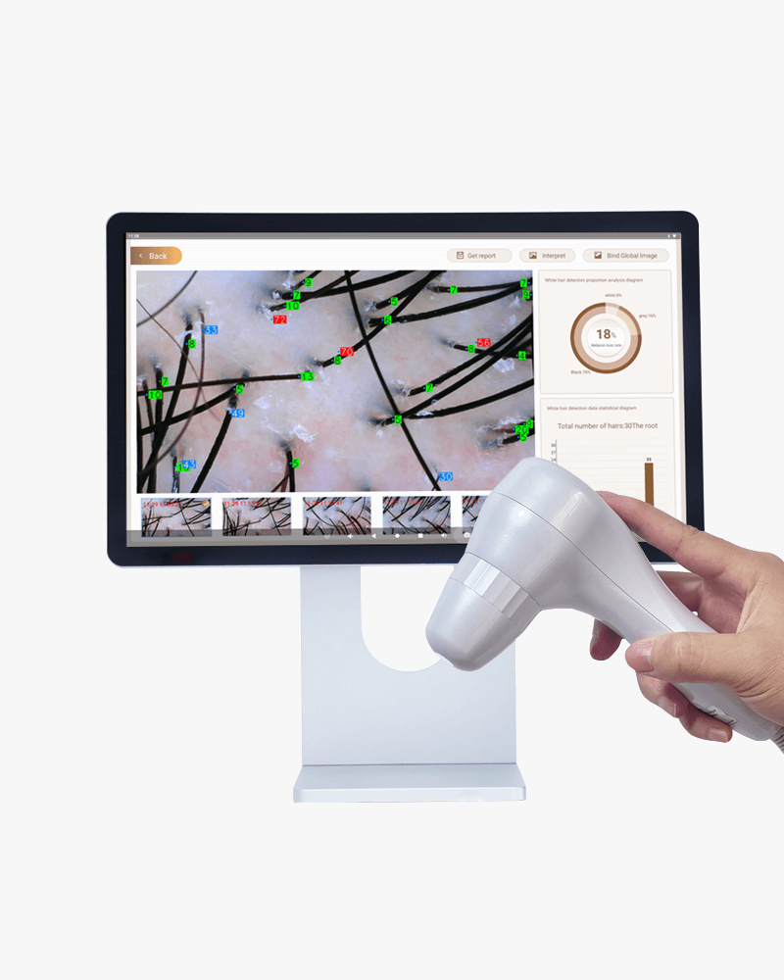
- A quantum food scanner that checks freshness or calorie content instantly.
- A smart home powered by quantum sensors adjusting light, heat, or energy automatically.
- A quantum hair analyzer that scans hair structure and recommends perfect care.
Ask:
- “What do you see?”
- “What could these things do?”
Step 2 – Simplified Input (3 min)
Explain simply:
“Quantum technology uses very small particles to make machines faster and smarter.
It can help chefs cook better, electricians save energy, and hairdressers personalize care.”
Step 3 – Quick brainstorm (5 min)
On the board, create three columns:
Cook | Installer | Hairdresser
Students call out ideas (“smart fridge”, “automatic lights”, “hair color scanner”) — teacher writes them.
Vocabulary Pre-teach (10 min)
Show key words (on slide/handout):
- Quantum sensor
- Smart device
- Energy saving
- Data
- Analyze
- Detect
- Automatic
- Freshness / Texture / Color
Use pictures and tools from their fields.
Ask: “Which word could match your job?” → confirm meaning together.
Reading & Comprehension (15 min)
Divide by vocation — each group gets a short text (80–100 words).
Cooks: Quantum Cooking
Key vocabulary:
- temperature sensor
- molecule
- precision
- freshness
- flavour
Reading:
In the future, quantum sensors will help chefs cook with perfect precision. They can measure the temperature and composition of food at the molecular level. They can also detect if food is fresh or spoiled faster than our senses.
Tasks:
1. Match the words with their meanings:
a) molecule the taste of food
b) flavour how new or not spoiled something is
c) freshness the smallest part of a substance

2. Fill in the blanks:
Quantum sensors can measure __________ and detect __________ of food.
3. Creative task:
Create a “Quantum Menu” item. Write the name of one dish and explain in 1–2 sentences how a “quantum cooking device” helps prepare it.
Installers: Quantum Homes
Key vocabulary:
- sensor
- smart home
- electricity
- water flow
- safety
Reading:
In the future, quantum sensors will monitor water, gas, and electricity in houses with extreme precision. Smart homes will use these sensors to detect problems before they happen, improving safety and saving money.
Tasks:
1. Match the words with their meanings:
a) safety movement of water through pipes
b) water flow a house with intelligent electronic systems
c) smart home being free from danger
2. Fill in the blanks:
Quantum sensors can detect problems in __________ and improve __________.
3. Creative task:
Draw a simple plan of a “quantum smart home” in your notebook. Write 3 English sentences about how quantum sensors make the home safer.

Hairdressers: Quantum Beauty
Key vocabulary:
- hair analysis
- treatment
- damage
- beauty device
- precision
Reading:
Quantum devices will help hairdressers check the health of hair and skin in detail. They can detect damage invisible to the eye and suggest the best treatment for every client.
Tasks:
1. Match the words with their meanings:
a) damage a special care method for hair
b) treatment exactness or accuracy
c) precision harm or breakage
2. Fill in the blanks:
Quantum devices can detect __________ and recommend the best __________ for the hair.
3. Creative task:
Write a short slogan in English for a “Quantum Hair Device” and describe two advantages.
Research task – The Future of Your Vocation (20 min)
- Use the internet to find 3–5 real examples (articles, videos, news) showing how quantum or advanced technologies might change your job in the future.
- For each example, note:
a) Which technology or device is mentioned.
b) How it could change your job (make it easier, faster, safer, more creative).
c) What possible problems or challenges might appear (cost, skills, client acceptance).
- Prepare a short group presentation (2–3 minutes) that includes:
- One future device or idea for your job.
- Why it’s useful.
- What people would need to learn to use it.
- Be ready to answer:
- “Will this device replace humans?”
- “How can you prepare to use it in your career?”

Suggested Online Sources for Students
Field | Source | Description
Cooking / Food Tech | SPICE: Smart Projection Interface for Cooking Enhancement | Smart projection system showing cooking steps on kitchen surfaces.
 | Autonomous Cooking with Digital Twin Methodology | AI-powered cooking control system using sensors and simulations.
 | The Quantum Advantage in Food Systems | Explains how quantum computing could optimize food production.
Hairdressing / Beauty | Why Unilever Thinks Quantum Computing Could Be the Future of Beauty Innovation | Real-world example of a beauty company exploring quantum technology.
 | The Future of Beauty Tech: Insider Insights | Predicts trends in personalized beauty and AI/quantum-based devices.
 | Beauty Tech – Customer Experience and Loyalty | Academic article on digital and AI tools in the beauty industry.
Home Installations / Energy | Smart Nanomaterials to Support Quantum-Sensing Electronics | Future materials that could improve smart home energy sensors.
General Quantum Progress | Tiny Cryogenic Device Cuts Quantum Computer Heat Emissions by 10,000 Times | Real advancement in quantum computing technology.
*With NotebookLM, students chat with their sources, ask questions to find the main ideas, make the text easier to understand, and organize what they learn using mind maps.

Group Presentation (10 min)
Each group presents their Quantum Future Idea:
- Cook – Quantum menu item
- Installer – Smart home design
- Hairdresser – Quantum hair device slogan
Then hold a short Q&A:
“Which idea is the most futuristic?”

Wrap-up & Reflection (5 min)
Class discussion:
“Which job will change the most with quantum technology?”
Exit Ticket:
- One new word I learned: __________
- One new idea I discovered: __________

Assessment

Category | Criteria
Vocabulary & Reading Tasks | Understanding and accuracy
Creative Task / Presentation | Originality, clarity, connection to profession
Research Engagement | Use of sources, relevance, explanation
Participation & Collaboration | Active role in discussions and feedback

