European Rivers as Victims and Solutions of Climate Change
Age: 15–17
Duration: 3 lessons (each 45 min)
Interdisciplinary lesson: Geography; Biology / Environmental Science; ICT / Digital Literacy; English / EFL ; Art & Design ; Citizenship / Civic Education ; Media Literacy
Context
Climate change has dramatically affected European rivers, from droughts and floods to biodiversity loss. Yet, rivers also hold the key to many solutions—renewable energy, natural flood control, and ecosystem restoration.
In this project-based lesson, students become river ambassadors: researchers, digital creators, and storytellers who use AI and multimedia to explore how rivers are both victims and agents of change in the climate crisis.
Methodology
This lesson combines inquiry-based and project-based learning, allowing students to explore real-world climate change impacts on European rivers and create AI chatbots or “talking rivers” as a meaningful, hands-on project. Collaborative learning is embedded through group work and structured peer feedback (3C Peer Protocol), while digital and media literacy is developed as students evaluate and curate credible multimedia sources. Multimodal expression ensures inclusion and engagement, as students present findings through chatbots, audio, and interactive maps. Finally, reflective learning encourages students to consider human responsibility toward protecting natural ecosystems.

Learning Objectives
Students will:
- Identify how climate change affects European rivers locally and globally.
- Analyze causes and consequences for biodiversity, water levels, and human life.
- Find and interpret evidence of natural disasters and good environmental practices using reliable multimedia (videos, articles, podcasts).
- Use digital tools to collaborate, curate findings, and present them creatively.
- Create AI chatbots or “live talking rivers” to deepen understanding of chosen rivers.
- Reflect on human responsibility for protecting natural ecosystems.
Prior Knowledge
- Basic facts about European rivers and their ecosystems.
- General causes and effects of climate change.
- Skills in safe online research and source evaluation.
- Introductory understanding of AI or chatbot tools (teacher models if needed).
Materials & Tools
- Interactive map of European rivers (Genially)/Internet access, projector/smartboard/Tablets or laptops/Padlet for collaboration/AI chatbot tool (e.g., SchoolAI)
1. Warm-up / Activation (10 min)
- Prompt: “If a river could speak, what would it say about climate change?”
- Students post their ideas on Padlet → teacher connects their responses to the concept of rivers as witnesses and victims.
- Check for understanding: Students identify one local sign of change (flood, erosion, loss of species).
2. Exploration: Research & Evidence Hunt (25 min)
- In groups, students “adopt” a European river and collect multimedia evidence (videos, articles, audio) of climate impacts and positive actions.
- Each group uploads sources to a shared interactive map (Genially).
- Interpretation focus: Students don’t just gather facts—they summarize each piece as:
  - What happened?
  - Why did it happen?
  - What was done to help or adapt?
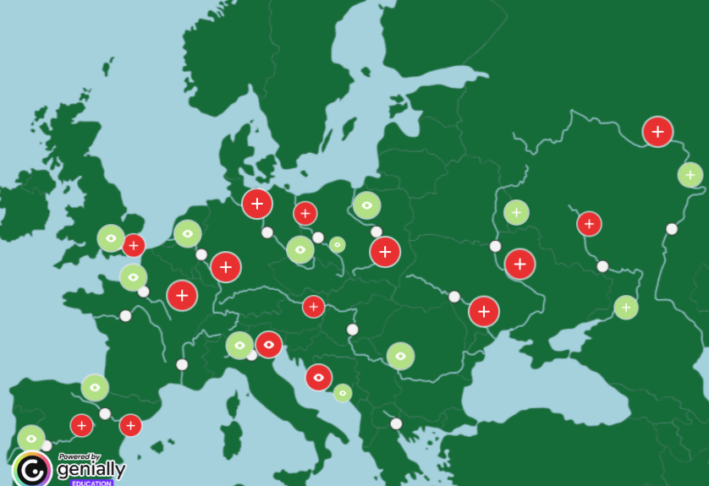
MEDIA LITERACY
Built-in check: Each group validates at least one source’s reliability
- Use the 3W Rule: Who, When, Where
- Each group answers these three quick questions for every source:
- Who created or published it? (journalist, organization, NGO, government, YouTuber?)
- When was it published? (is it recent or outdated?)
- Where does it come from? (official website, science platform, social media?)
- Cross-Check Information
Students look for the same fact in at least one other reliable source.
If two different reliable sites confirm it → it’s likely valid.
If only one blog or random video mentions it → discuss and label as “needs verification.”
- Spot Bias and Purpose
Ask:
- “Is this source trying to inform, persuade, or sell?”
- “Does it use emotional language or present data objectively?”
Use color-code on Padlet:🟢 reliable | 🟡 partly reliable | 🔴 biased/unclear
- Collaborative Check
- Each group presents one chosen source to another group.
- Peers review it and confirm or question its reliability (using the same 3W Rule).
- They record results on the shared Genially map, e.g. “Checked by Team Danube.
3. Collaborative Learning Check (10 min)
- Groups meet in pairs (peer partners) to explain what they’ve found so far.
- Each group gives short feedback using the “3C Peer Protocol”:
  - Cite: Mention one useful piece of evidence from the other group.
  - Connect: Link it to your own findings.
  - Clarify: Ask one question that could improve interpretation.

Example: Collaborative Learning Check (3C Peer Protocol)
Context:
Group A studied the Danube River.
Group B studied the Rhine River.
Both groups meet to exchange findings.

CITE – Mention one useful piece of evidence
Group B says:
“You mentioned that the Danube’s water temperature has risen by 2°C in the past 50 years — that’s a strong piece of evidence about how climate change affects biodiversity.”
Why this matters: Students identify what’s valuable and show they’ve listened actively.

CONNECT – Link it to your own findings
Group B continues:
“We found something similar for the Rhine — warmer water led to a decline in salmon populations. It’s interesting how both rivers are losing native species.”
Why this matters: Students make cross-river or cross-context connections → seeing patterns and shared challenges.

CLARIFY – Ask one question to improve interpretation
Group B asks:
“Do you know if the Danube’s temperature rise is mainly due to global warming, or could industrial waste and local pollution also play a role?”
Why this matters: Encourages deeper analysis — moving from “what” happened to “why.”
- Teacher monitors and notes collaboration quality.
4. Deepening Understanding: Create a “Talking River” or AI Chatbot (30 min)
- Using collected evidence, groups design a digital “talking river”—a chatbot or avatar that shares its story, combining factual data and human emotion.
- Example: “I’m the Sava. I’ve endured floods, but restoration projects gave me new life.”
- Interpretation built-in: Each chatbot must include at least one verified problem and one documented solution from the group’s research.
- Teacher check: Visits groups, asking, “How does your river’s story connect with real evidence?”
5. Presentation & Peer Feedback (15 min)
- Groups present their chatbots or recorded river voices.
- Peers use “Glow & Grow” feedback (1 strength + 1 suggestion).
- Class discussion: “What do all rivers have in common?” “Where do we see hope?”
6. Reflection (10 min)
- Students respond (in writing or audio):
  - “What surprised me most about my river’s story?”
  - “How can technology help protect nature?”
- Optional: share short quotes in Padlet “River Reflections Wall.
7. Wrap-up (5 min)
- Class creates a Mentimeter word cloud: “One word that describes the future of rivers.”
- Teacher highlights recurring values — collaboration, hope, accountability.
Assessment
Formative:
- Active participation and teamwork
- Accuracy and interpretation of evidence
- Quality and creativity of AI/chatbot product
Summative (Rubric):
- Depth and reliability of research
- Interpretation of cause–effect relationships
- Creativity and coherence in presentation
- Collaboration and reflection
Homework / Extension
- Find a local article or report about your hometown river and summarize its current challenges and adaptation efforts.
Teacher Reflection
- Did students move from collecting to interpreting and explaining information?
- Did collaborative checks enhance understanding and peer learning?
- How effectively did AI storytelling support engagement and environmental empathy?

