EU Values IRL: Spot it, Name it, Change it
Values in Action: Gen Z for a Better Europe
Target Group:
Teenagers (14–17), inclusive of mixed-ability learners
Can be adapted for SEN and vocational schools
Duration:
90 minutes (can be split into two 45-minute sessions)
Learning Goal:
Students will be able to:
- Identify violations of EU core values in everyday life (online/offline)
- Critically reflect on their causes and consequences
- Propose respectful, inclusive alternatives aligned with EU values

SESSION FLOW:
Spark Curiosity (10 min)
Title: “What Are EU Values?”
- Watch: Video: What are EU values?
- Turn & Talk: “Which value stood out to you most and why?”
Brainstorm – “Where Are the Cracks?” (10–15 min)
Tool: Mentimeter / Padlet
Prompt: “Where do you see disrespect for human dignity, freedom, democracy, equality, rule of law, or human rights in your everyday life?”
Team-Based Investigation (30 min)
6 Groups – Each assigned one EU value.
Each group receives:
- 2–3 anonymized real-life examples (teacher-provided or AI-generated from Perplexity)
- One interactive AI chatbot (e.g. Mia, a Roma girl; Luka, a bullied teen)
- Analysis Template:

Analysis
Which VALUE is being violated?
Who is affected?
Why is it wrong?
How could the situation have been handled differently?

Real-World Meme Review (10 min)
Students review actual memes or screenshots:
- Decide which value is being violated
- Who is harmed?
- Reflect using the same analysis questions

Interactive AI Roleplay (10 min)
Tool: AI-powered chatbot (e.g. Poe, ChatGPT)
Example prompt: “Talk to Mia, a 16-year-old Roma girl who was excluded from a school project…”
Students must:
- Ask 3–5 empathetic, critical questions
- Summarize how EU values could protect her rights

Creative Output – Digital Wall of Respect (15 min)
Each team designs a “Violation vs. Value” Interactive Poster, with:
- Real example (meme, screenshot, case)
- Analysis (What happened? Why is it a violation?)
- Proposed solution
- Student-made meme/slogan/call to action

Game-Based Reflection – Sorting Game (10 min)
WordWall: Match the Situation to the Value
Values at school level
Possible Violations of EU Values at School
Each example is linked to one of the six EU core values
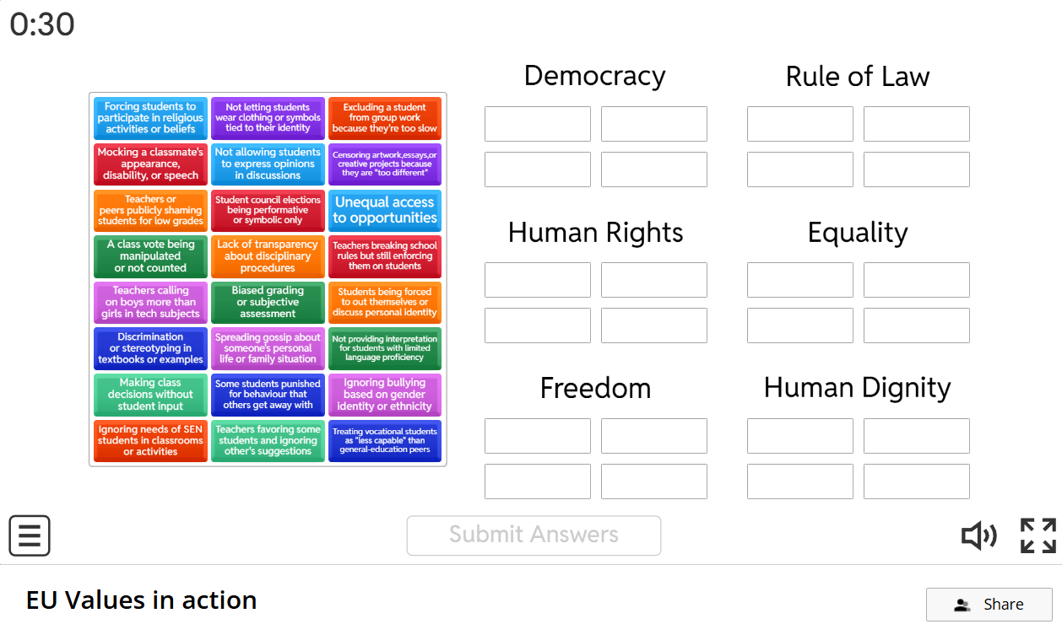
1. Human Dignity
Everyone has the right to be treated with respect, no matter who they are.
2. Freedom
Freedom of thought, religion, and expression must be respected.
3. Democracy
Everyone should have a voice and be able to participate.
4. Equality
Everyone should be treated equally, regardless of background.
5. Rule of Law
Rules must be clear, fair, and apply to everyone.
6. Human Rights (especially minority rights)

https://learningapps.org/display?v=p5ia0mdok25
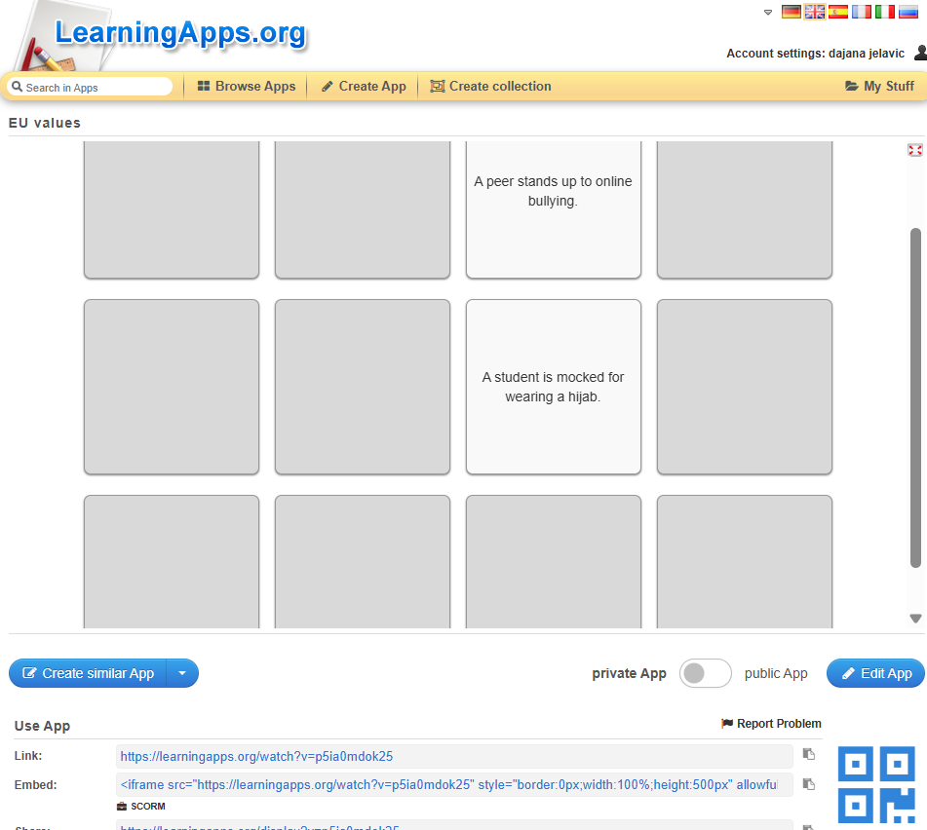
Find pairs!
How to Play:
- Each card has a situation
- And related EU value
Students have to find the matches!

Assessment
Rubric for interactive poster Violation vs. Value Final score 20
Criteria | Excellent (4 pts) | Good (3 pts) | Emerging (2 pts) | Needs Work (1 pt)
1. Value Identification | Correctly identifies the EU value and links it clearly to the situation | Identifies the correct value with some explanation | Some confusion about the value; vague explanation | Incorrect or missing value
2. Impact & Reasoning | Clear, thoughtful analysis of who is affected and why it matters | Reasonable explanation of the impact | Some understanding, lacks depth | Little or no explanation of the impact
3. Inclusive Solution | Offers a respectful, realistic and value-based response | Offers a decent solution, mostly aligned with values | Solution lacks clarity or relevance | No clear solution provided
4. Creativity & Visual Design | Poster is engaging, well-designed, includes original visuals or slogans | Poster is visually clear with some creative elements | Poster is basic; lacks visual appeal | Unclear, messy, or minimal effort
5. Teamwork & Communication | All team members contributed and worked well together | Most members contributed equally | Some participation issues | One person did most of the work or teamwork unclear

