Design Your Green Day: Sustainable Practices in VET

Target Group: Separate sessions for cooks, hairdressers, installers and waiters (adaptable for other VET students). Class 3d 2025/26
Inclusive Strategies:
Differentiated roles, visual instructions, multilingual templates, pair work with peer support, speech-to-text options, drawing or voice-based alternatives.
Duration:
2–3 sessions (45 min each) + 1 implementation/exhibition day
Learning Objectives
By the end of the unit, students will be able to:
- Remember/Identify harmful practices in their field (knowledge)
- Understand/Describe sustainability principles (comprehension)
- Apply eco-friendly practices in real or simulated contexts (application)
- Analyze vocational habits needing improvement (analysis)
- Create a collaborative action plan/event (synthesis)
- Evaluate effectiveness using feedback tools (evaluation)
Lesson Structure (3 Phases)
Phase 1 – Problem Spotting: “My Piece of the Puzzle” (25 min)
- Students receive a blank puzzle piece (physical or digital)
- Side A: Draw/write a harmful practice in their profession
- Side B: Suggest a sustainable alternative
- Scaffolding Options: Sentence starters (“Instead of ____, we can ____”), dictation, speech-to-text, drawing, voice notes
Goal: Students recognize and articulate unsustainable habits in their field.
Phase 2 – Solutions & Mosaic Assembly (30 min)
- Mosaic Assembly (15 min):
  - Students present their puzzle pieces
  - Assemble them on a board to create a collective mural
  - Gallery walk: students give feedback with sticky notes or comments
- Team Challenge (15 min):
  - Small groups select 1–2 ideas from the puzzle
  - Design a simple sustainable improvement plan using guiding questions:
    - What needs to change?
    - Who is involved?
    - What materials/habits are needed?
    - How can clients/customers be informed?
  - Output options: poster, slide, drawing, mind map, role-play
Goal: Students analyze and design actionable, sustainable solutions.

Phase 3 – Chatbot Tutor Integration (20 min)
- Each group creates a basic chatbot tutor for their profession using a simple AI/chatbot tool (e.g.Schoolai)
- Function: The chatbot answers questions about sustainable practices in their vocation, guiding peers through eco-friendly habits
Goal: Deepen knowledge retention, reinforce solutions, and provide a peer-teaching tool for long-term learning

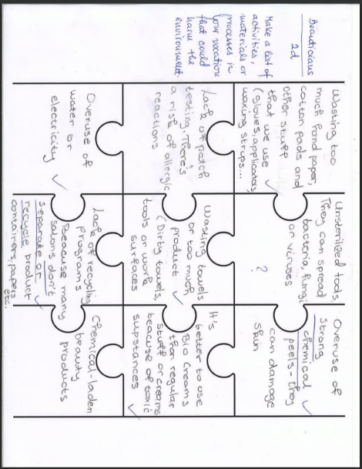

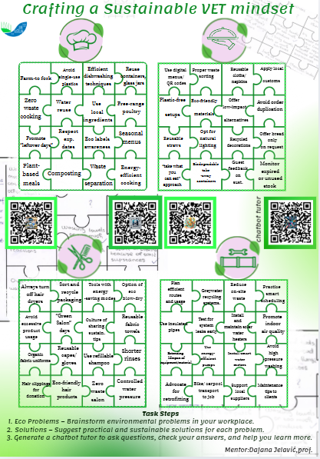

Design Your Green Day (45–60 min)
Each vocational group designs a themed day to showcase sustainable practices.
Cooks – Green Kitchen Day
- Create a low-waste seasonal menu
- Design food labels showing environmental impact
(Designing food labels that show environmental impact means creating labels that inform consumers about how a particular food item affects the environment. These labels aim to promote eco-conscious choices and increase transparency about how food is grown, processed, packaged, and transported.)
- (Include a poster: “Eat Local – Save Global”)
Example: 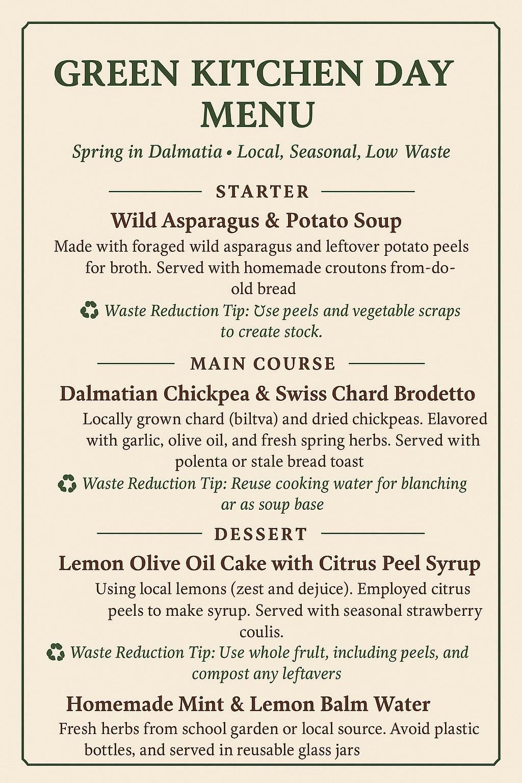 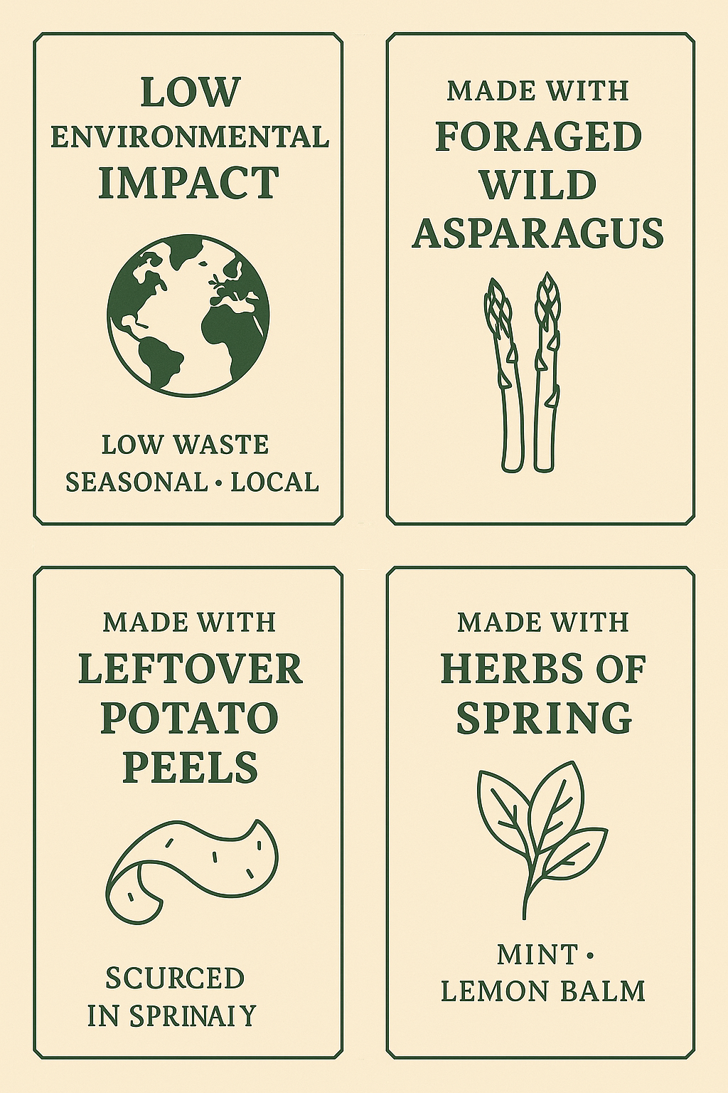

Assessment
Formative / Process
Teacher observation | - Engagement in discussions  - Teamwork & role contributions  - Critical thinking during design phase  - Use a checklist with clear, visual criteria
Exit Slip (at the end of each session) | - “Today I discovered that…”  - “One idea I will try in real life is…”  - “I was surprised to learn that…”  (Exit slips can be drawn, written, spoken ,recorded on phones, or typed.
Product/Performance Assessment

Green Day Materials | - Relevance and clarity of content  - Visual appeal and creativity  - Real-world applicability
Group Presentations | - Clear communication  - Demonstration of vocational knowledge  - Inclusion of clients or real-world context
Self-Assessment Sheet | - What I learned  - What I contributed  - What I would improve next time

Final Reflection:
Students take a picture of the final mosaic, sign it, and write one personal eco-commitment on a green leaf-shaped paper to hang nearby.

