eTwinning FOR ENTREPRENEURIAL EDUCATION: DEVELOPING THE NEXT GENERATION OF INNOVATORS
Use the following template to develop and share a lesson plan, that focuses on Entrepreneurship and Entrepreneurial Education, that you could develop during a European eTwinning project with your students. Please fill in all required sections to provide the reader with enough information. The template should be filled only in English.
Please replace the words in blue with your own information

Author
Dajana Jelavić

Table of summary
Activity Title | USING MYTHS for PROBLEM-SOLVING  (Page: Let’s create myths together!) Subpages: Environmental issues; Bullying: Digital gap; Procrastination, Other….
Context | The eTwinning project "Whispers from the past" provides an immersive and interdisciplinary approach to learning, encouraging students to apply their language skills in a meaningful context. It includes collaboration of three secondary schools and two elementary schools located in historically rich cities. This project is a holistic educational experience, blending cultural exploration, technological proficiency, collaborative learning, and the monitoring of the entrepreneurial competencies’ development. By presenting narratives of local myths with a creative twist project results will transform tourism experiences, making them sustainable and culturally enriching. In this process entrepreneurial competences are being developed by tracking and reflecting upon with focus on problem-solving but in an innovative way following the rules and structure of myths (growth mindset). This activity is central one and could be included after students’ research on local myths and legends.
Objectives | The objectives of the activity:  - enhance cultural awareness and appreciation for diversity and inclusion  - improve English skills in research, presentation, and communication  - introduce innovative ways of problem-solving  - enhance digital literacy skills using technology tools  - adopt a culture of continuous improvement by tracking EntreComp
Preparation and Teacher’s role | - providing resources (myth structure, topics to cope with and rubric for myth writing)  PLANNING YOUR MYTHS  - Where does your myth take place?  - How will you describe your hero or heroine? What characteristics will they have? Who were his/her parents? Are they the son or daughter of a God or Goddess?  - What is the problem, quest or challenge that your hero or heroine has to deal with?  - Does your hero or heroine have any special powers or weapons from the Gods?  - Will your myth include a fantastical beast or monster that your hero or heroine has to deal with?  - Will your hero or heroine have to go on a long journey? Where will they have to travel to? How will they get there?  - How will your myth end? Will the hero or heroine win something? Will your hero or heroine save the world from catastrophe?  - What issues from your surrounding would you like to solve?  - What traits of entre mindset can be found in your myth? (Perseverance, adaptability, risk taking, leadership, collaboration, time management…….  - International teams are set.  - Let's start problem-solving collaboratively! Open a shared document and begin drafting new myths.  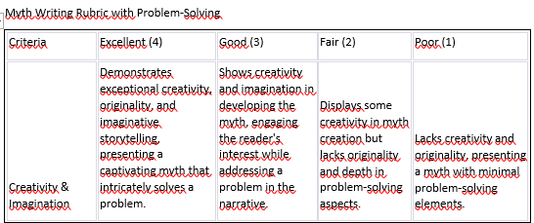  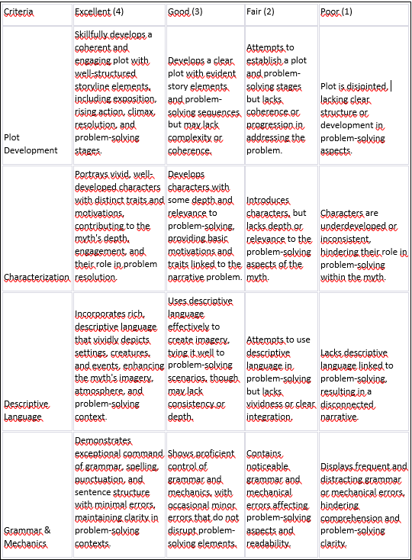  - brainstorming creative ways to solve real-life issues  - assisting by expanding vocabulary, suggesting language structures  - facilitating international teamwork and collaboration  - offering constructive feedback, monitoring progress, and encouraging reflection
Collaboration among teachers | - introduce the activity’s objectives  - discuss each school's strengths, resources, and available technology for the activity  - assign a mentor/facilitator from each school responsible for communication and coordination of international teams  - research and collectively select ICT tools suitable for transforming myths into innovative project  - conduct training sessions or workshops on these selected tools for teachers and students  - divide responsibilities among schools for specific activity phases considering their expertise  - designate tasks such as research, analysis, creative interpretation, content creation, collaboration, and presentation  - schedule regular online meetings or video conferences to discuss progress, challenges, and adjustments needed  - share updates, exchange ideas, and provide support across schools  - plan a joint virtual meeting where international teams can present their work to peers and get a feedback and suggestions for improvement  - gather new myths and legends and publish a digital book  - teachers allocate time for reflection after the activity completion to assess the impact, lessons learned, and future improvements  - share evaluation reports and insights among schools
Instructions for teachers | - Introduce students to the activity USING MYTHS for PROBLEM-SOLVING  - Activity objectives:  -enhance cultural awareness and appreciation for diversity and inclusion  -improve English skills in research, presentation, and communication  -introduce innovative ways of problem-solving  -enhance digital literacy skills using technology tools  -adopt a culture of continuous improvement by tracking EntreComp  - Establish international teams and assign a single teacher from each school to mentor/facilitate a team  - Introduce ICT tools (Google doc, Lumen5, Bookcreator, Ideogram.ai, etc.)  - Assist students in utilizing these tools  - Facilitate collaborative work among students, provide guidance and support if needed  - Encourage continuous reflection in Loop.me  - Carry out formative assessments (evaluating myths according to rubric, reading comprehension check, self-assessment)  - Facilitate virtual meeting and welcome any improvements suggested by the peers  - Publish a joint digital book paying attention on proper illustration being used
Time | A suggested time limit might span around 4-8 weeks. However, the specific timeframe could be adjusted based on the students' proficiency levels, and the depth of the entrepreneurial and language skill development intended as well as other circumstances and obstacles that may occur in virtual projects.
ICT tools used for this activity/activities | Shared Google document-for collaborative writing (enables sharing creativity in creating joint final result, at the same time developing teamwork, negotiation, communication, empathy and other soft skills)  Title generator-for myths and legends titles (enables crafting captivating and creative titles to attract attention to their work effectively)  Lumen5-explanatory video to showcase the real life problem and its solution highlighting entre skills used (The added value of Lumen5 lies in its capacity to transform students' interpretations of myths into attractive visual narratives that enables deeper understanding and retention).  Bookcreator-collection of literary works (fosters digital publishing skills and presents the project result in an accessible format)  Ideogram.ai-image creator to illustrate a collection (enables visual storytelling, allowing students to depict myths graphically enhancing their creativity, artistic expression, and comprehension of narratives through visual representation)  Formative assessment:  - Teacher’s feedback  - Gibbly-reading comprehension check (collaborative assessment creation, facilitating seamless teamwork)  - QuestionPro- self-assessment (gathering feedback)  - Loop.me-reflection/tracking development using skills’ tags
Description of the activity/activities | Welcome to our eTwinning project, 'Whispers from the Past,' where we harness the power of myths for innovative problem-solving! This project unites five schools from historically rich cities whose students will delve deep into the narratives of myths, extracting valuable lessons, patterns, and themes that offer creative solutions to modern-day challenges.  In this activity students have to choose one of the problems from the subpages or add their own one and try to find a solution writing collaboratively a new myth. International teams are formed consisting of one representative from each school/country. Each team will share a document (Google doc) and start dealing with chosen problem following the structure and rules of myths ( resource: Planning your myth is provided as well as a rubric that will be used later for assessment).All myths will be collected and published in an e-book (Bookcreator). One team member will create illustrations using AI tool(Ideogram.ai). Throughout this creative process, students should leave their reflections on a platform (Loop.me) that tracks entrepreneurial skills development. Another team member will create an explanatory video (Lumen5) to show which entre competences are needed to solve their problem and what kind of problem they want to solve. This video is vital to enhance awareness of entrecomp importance for problem-solving. At the end students will create collaborative reading comprehension check (Gibbly). Peer review will be also included in the final online meeting where each team will present their new myth. Dear students, if you need any clarifications, don't hesitate to reach out to your team mentor for guidance. Happy writing!
Outcome of the activity/ Presentation | A tangible outcome of the activity is a collaborative, illustrated collection of myths (e-book) that can be further used for educational purposes as a resource offering solutions for various issues.  Another tangible outcome involves the analytics and data generated by Loop.me, which will demonstrate the development of entrepreneurial competencies throughout the activity.  Next tangible outcomes include videos created by Lumen5; collaborative comprehension check made by Gibbly and collection of illustrations made by Ideogram.ai  Intangible outcomes are enhanced awareness of entrecomp importance; enhanced problem-solving skills; enhanced creative and innovative skills; among other transversal ones.  The activity will be disseminated in the school community and wider as an example of good practice at educational meetings, workshops and webinars, it will be also presented to Tourist Board and posted on school social media and Erasmus FB page.  The students will present this activity online to our Erasmus partners and face to face at school, giving presentations.
Assessment | Formative assessment:  - Rubric for myths writing  - Teacher’s feedback  - Peer review  - Gibbly-reading comprehension check  - QuestionPro- self-assessment  - Loop.me-reflection/tracking development using skills’ tags
eTwinning School Mission | This activity plan integrates several aspects that resonate with the eTwinning School Mission principles, including collaboration, innovation, cultural understanding, digital citizenship, fostering an entrepreneurial mindset, and promoting teacher collaboration.
European School Education Platform and eTwinning are initiatives of the European Union and funded by Erasmus+, the EU’s programme to support education, training, youth and sport in Europe. This document has been prepared for the European Commission by European Schoolnet under a contract with the Union, however it reflects the views only of the authors, and the Commission cannot be held responsible for any use which may be made of the information contained therein.

