Project Plan: "Taste and Escape Across Croatia"
1. Project Overview
Title:
Taste and Escape Across Croatia – Explore Croatia's Culinary Delights by Region in an Interactive Escape Game
Target Group:
High school students (ages 15–17)
Project Duration:
6–8 weeks (adaptable)
Participants:
- Dajana Jelavić, EFL Teacher Mentor
- Students: Laura Škarica (3e), Lukas Brzović (2e)

2. Objectives
- Promote Croatian cultural heritage and regional diversity through cuisine.
- Foster student creativity, research, collaboration, and digital skills.
- Develop English language skills through authentic, meaningful tasks.
- Use gamification (escape room format) to boost motivation and engagement.
- Integrate digital tools (QR codes, Genially, Canva, etc.) in project work.

3. Project Phases
Phase 1: Research and Content Creation (Weeks 1–2)
- Students form teams and select a region of Croatia (e.g., Istria, Dalmatia, Slavonia, Lika, Zagorje).
- Research typical dishes, ingredients, food customs, and cultural highlights.
- Write short informative texts in English about each region's cuisine.
- Find or create photos and multimedia content.
Phase 2: Designing Escape Challenges (Weeks 3–4)
- Design tasks for the Escape Room:
  - Riddles
  - Puzzles
  - Matching pairs
  - Hidden clues
  - Quizzes
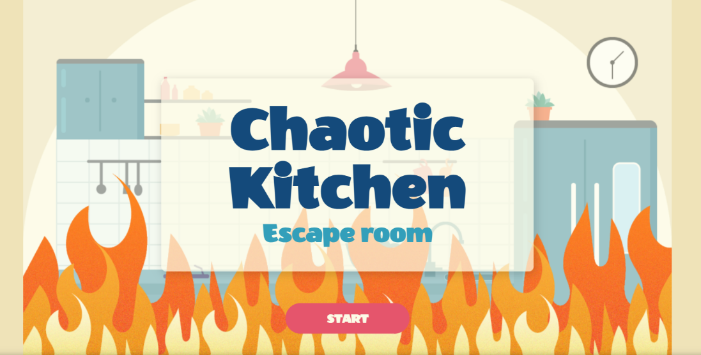

Phase 3: Digital Creation (Weeks 5–6)
- Create an interactive poster:
  - Insert QR codes linked to online challenges (Genially)
  - Arrange visual elements (doors, keys, windows, regional images) on a Croatia map background.
- Test QR codes to ensure they work properly.
Međimurje
https://view.genially.com/67c6d59f253258eeafd5b796/interactive-content-medimurje
Lika https://view.genially.com/67c6d5e2384d00b8367a18e0/interactive-content-lika
Istria https://view.genially.com/679b84b11aad9ac835a149cc/interactive-content-lukas-nikola-gabriels-chaotic-kitchen-escape-room
Dalmatia https://view.genially.com/6739ae4c5d3cb64d9298d9e6/interactive-content-3chaotic-kitchen-escape-game
Slavonia https://view.genially.com/673f3b92cce65c7ad5f13ffb/interactive-content-2chaotic-kitchen-escape-game
Phase 4: Presentation and Launch (Week 7)
- Organize a school exhibition day:
  - Display the poster.
  - Invite students, teachers, and guests to play the escape game.
- Encourage feedback via a short online survey.
Phase 5: Reflection and Evaluation (Week 8)
- Students reflect on what they learned (language skills, teamwork, digital skills, cultural knowledge).
- Discuss what worked well and how the project could be improved.
- Submit the project for potential competitions or exhibitions.

4. Materials and Tools Needed
- Computers/tablets
- Internet access
- QR code generator (e.g., QRCode Monkey)
- Canva/Genially for creating digital tasks
- Printer (for poster printining)

5. Expected Outcomes
Students improve English communication and research skills.
Increased knowledge of Croatian cultural and culinary diversity.
Enhanced teamwork and project management abilities.
Practical experience with digital tools and gamification.
A fully functional, interactive poster for school use or exhibitions.

Credits:
Writing supported by ChatGPT, an AI developed by OpenAI, with educational guidance by Dajana Jelavić.

