Reshape Social Media for Well-being (Design Thinking Applied)

Learning Objectives:
By the end of the lesson, students will:
- Reflect on their personal experiences with social media and its emotional impact.
- Identify problems and create a solution to improve social media for mental well-being.
- Use the Crazy 8s method to brainstorm a variety of ideas quickly and creatively.
- Design a prototype of a social media platform focused on well-being using Canva to create a poster showcasing their design.
- Present their redesigned social media platform through a pitch using avatars/video.

Duration:
1–3 lessons (45–90 min each), depending on available time

Step 1: Survey – How social media makes You feel (20–30 mins)
Design Thinking Stage: Empathize
Objective:
Students will reflect on their own social media experiences and how it affects their emotions. This step focuses on understanding the user and gathering data to empathize with their needs.
Activity:
Social Media Mood Survey
- Introduction (5 mins):
  - Explain the purpose of the survey: “We’ll be exploring how social media impacts our feelings—both positively and negatively. Your honest answers will help us better understand how we use social media and how it affects our well-being.”
- Survey Questions & Results (15–20 mins):

- Analysis & Reflection (5–10 mins):
  - Discuss the results with the class to uncover common emotional patterns or issues.
  - Design Thinking Application: In this phase, students are building empathy by exploring the feelings and experiences of social media users. This is the foundational step of understanding the user and their emotional challenges.

Step 2: Empathize & Define the Problem (20–30 mins)
Design Thinking Stage: Define
Objective:
Students will use their survey data to create a persona and identify a key problem related to social media’s emotional impact. This is where students define the problem they are trying to solve.
Activity:
Persona Creation & Empathy Mapping
- Persona Creation (5–10 mins):
  - In small groups, students create a fictional persona (e.g., a teen influencer, gamer, or anxious student) based on survey results.
  - Example: "Lana, 16, uses social media for keeping up with trends but often feels anxious after scrolling through posts."
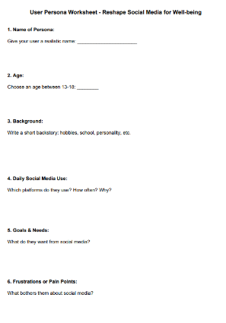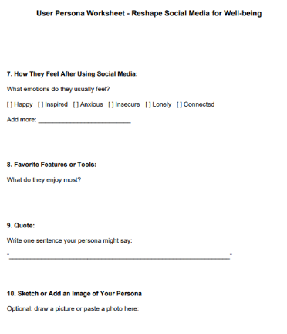
- Empathy Mapping (15–20 mins):
  - Use an Empathy Map to explore:
    - What does the persona see, hear, feel, think, and do on social media?
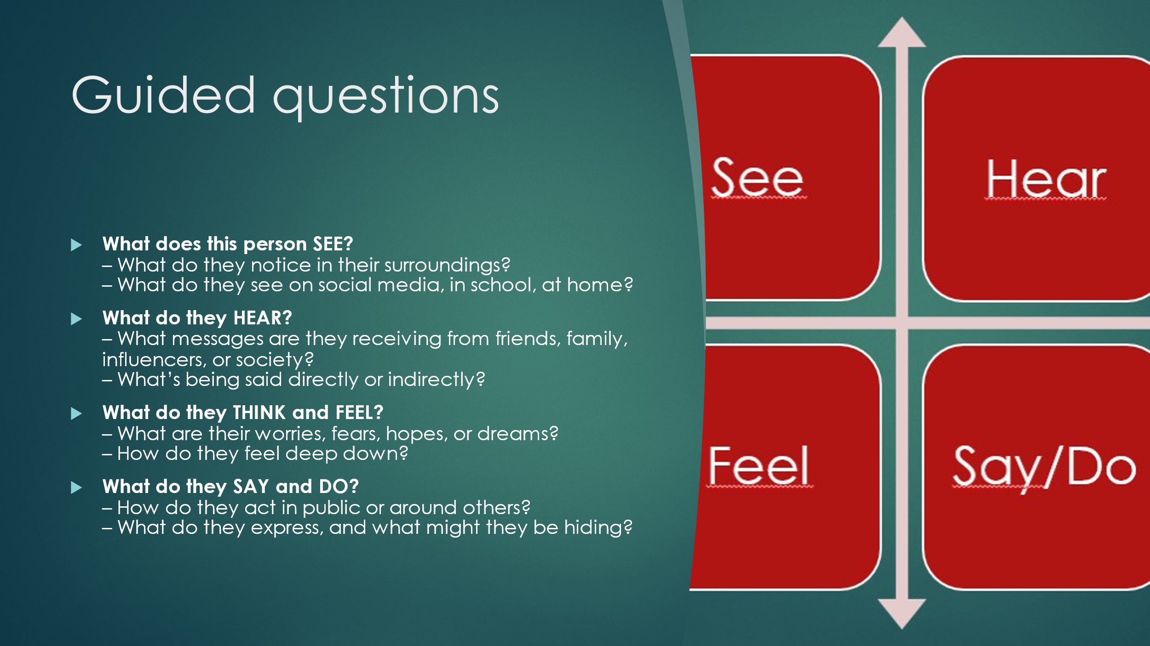
  - Define the problem: “How might we improve the social media experience for this persona?”
  - Design Thinking Application: In the Define phase, students synthesize insights from their empathy research and clearly define the problem they are solving. This step guides them toward identifying what needs to change in social media to support emotional well-being.

Step 3: Ideate Using Crazy 8s (30–40 mins)
Design Thinking Stage: Ideate
Objective:
Students will quickly generate multiple ideas for redesigning social media through a Crazy 8s brainstorming session. This encourages rapid, creative thinking and ensures a diverse range of ideas.
Activity:
Crazy 8s Brainstorming
- Introduction to Crazy 8s (5 mins):
  - Explain the Method:
“In this step, we will use Crazy 8s, a quick sketching activity to generate as many ideas as possible. Each person will fold a piece of paper into 8 boxes. Then, you’ll have 8 minutes to sketch 8 different ideas for social media features that could promote well-being.”
    - Why Crazy 8s works: This method helps generate a wide variety of ideas in a short period of time, forcing students to think quickly and avoid overthinking their designs.
    - Materials: Paper and pens, or a digital tool like Jamboard or Google Slides (if digital).
- Crazy 8s Activity (8 mins):
  - Students sketch 8 different ideas in 8 minutes, focusing on social media features that promote mental well-being (e.g., positive affirmations, mood trackers, digital detox timers, anonymous support forums).
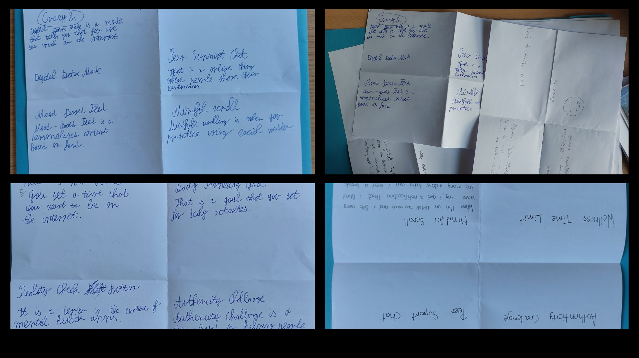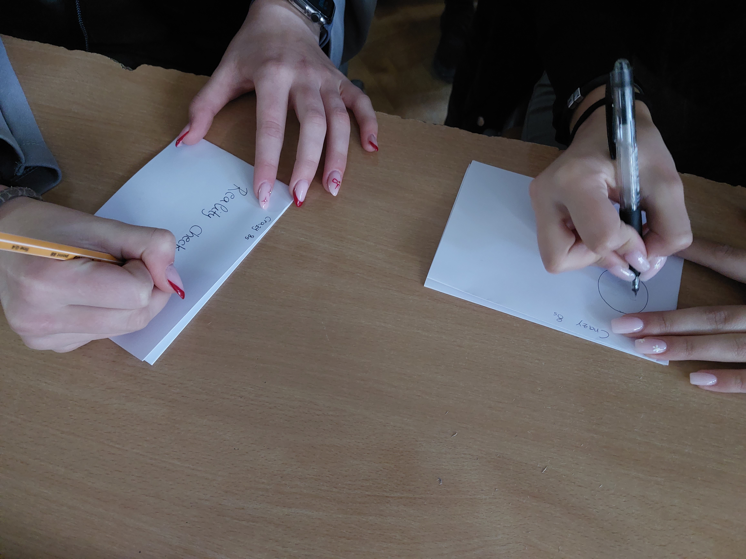
- Share & Discuss (15–20 mins):
  - After completing the Crazy 8s activity, students share their ideas with the group. Each student explains one of their sketches and how it contributes to improving social media for emotional well-being.
  - Discuss common themes and identify the most promising ideas to move forward with in the prototype phase.
  - Design Thinking Application: Crazy 8s is part of the Ideate phase, where students push themselves to think creatively and quickly. This encourages divergent thinking and allows students to explore many solutions before narrowing down their focus.

Step 4: Prototype Using Canva Poster (30–40 mins)
Design Thinking Stage: Prototype
Objective:
Students will create a prototype of their redesigned social media platform using Canva, turning their ideas into a visual representation on a poster.
Activity:
Create a Prototype Poster
- Introduction to Canva (5 mins):
  - Explain the Task: “Now that you have your ideas, we’ll use Canva to create a prototype poster of your new social media features. Your poster should showcase the key features for promoting well-being.”
- Create the Poster (25–35 mins):
  - Students design a poster that visually represents their ideas, including:
    - Key Features: Brief descriptions and visuals (e.g., mood tracking, time management, support communities).
    - Benefits for Mental Health: Clear statements about how it improves users' emotional well-being.
  - Design Thinking Application: The Prototype phase is where students create tangible representations of their ideas, testing their concepts through visual design. This step helps students refine their ideas into a form they can present and share.

Step 5: Shark Tank – Pitch Your Redesigned social media Using Avatars (20–30 mins)
Design Thinking Stage: Test
Objective:
Students will present their redesigned social media platforms using avatars. This step serves as a test of their ideas, as they will receive feedback from classmates acting as "Sharks."
Activity:
- Introduction to Animaker app. (5 mins):
  - Explain how avatars will represent the students during their pitch presentations.
- Pitch Preparation (10–15 mins):
  - Students create an avatar and prepare a 2–3 minute pitch/video, including:
Name/logo
    - Target Audience
    - Key Features (e.g., mood tracking, time limits, gratitude feeds)
    - Benefits for Mental Well-being
- Pitch Presentation (10–15 mins):
Guided questions:
- What is the name of the product, service, brand, company, platform, or app?
- What specific problem does this product, service, brand, company, platform, or app solve?
- What solution does it provide?
- How does it work or function?
- What are the benefits of using this product, service, brand, company, platform, or app?
- What is the call to action for this product, service, brand, company, platform, or app?

  - Each student presents their pitch using their avatar/video.
  - After each pitch, classmates ask questions or give feedback as "Sharks."
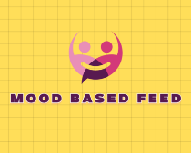

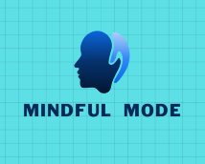
- Reflection & Feedback (5–10 mins):
  - Students reflect on feedback from their peers and consider improvements to their designs.
  - Design Thinking Application: In the Test phase, students receive feedback on their prototypes, which helps refine their designs and ensure their solution is practical and effective.

Tools/Materials Needed:
- Survey Tools: Google Forms or paper surveys.
- Design Tools: Canva.
- Animaker: For creating avatars and presenting pitches.
- Logo for your new social media feature.
- Empathy Map & Persona Templates: For defining the user and problem.
- Sheets of papers/Crazy 8s for brainstorming.
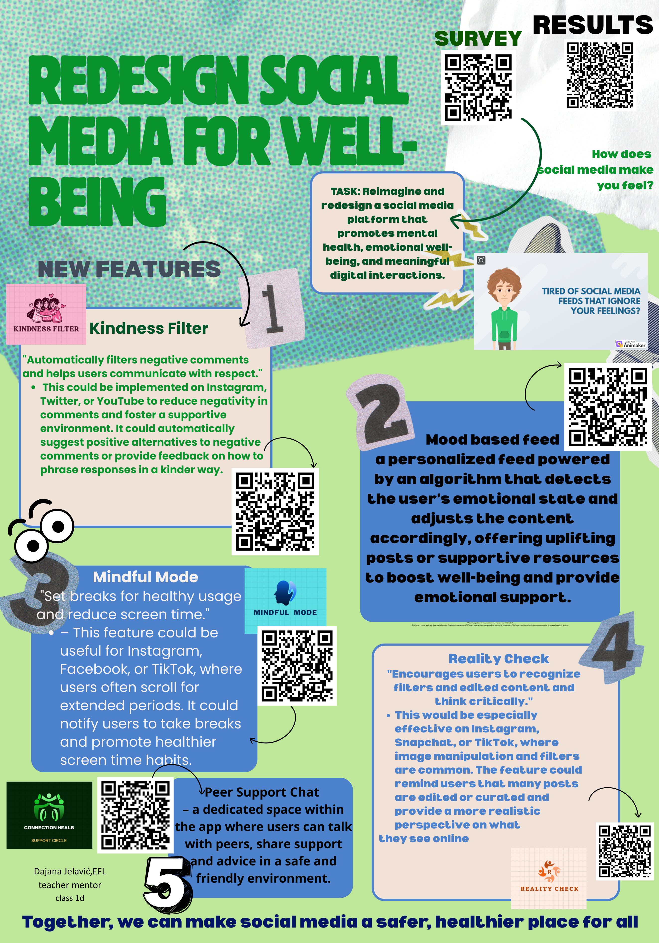

Assessment:
- Formative Assessment: Evaluate student participation in the survey, brainstorming, and empathy mapping.
- Summative Assessment: Review the final pitch presentation, prototype poster, and the use of feedback for refinement.

Credits:
Writing supported by ChatGPT, an AI developed by OpenAI, with educational guidance by Dajana Jelavić.

