Digital Sustainability – School Project Plan

# Project Objective

To raise awareness and promote sustainable digital habits among students through a blended learning approach, including surveys, discussions, educational videos, and gamified tools.

# Participants

- Students from multiple classes in secondary school “Jure Kaštelan” Omiš  
- Mentor: Dajana Jelavić,prof.

**Duration:** 3 months (September-December 2024)

# Project Activities

The project was structured in the following steps:

1. Initial Survey:  
- Students answered a survey designed to gauge awareness, attitudes, and behaviours regarding the use of digital technology in a sustainable way.  
- Key findings:  
 • About 50% of students were somewhat familiar with the concept of digital sustainability  
 • Only 20% were very likely to reduce screen time  
 • Almost 40% were not interested in taking any steps  
 • Nearly 40% responded neutrally to questions on e-waste recycling  
- The results highlighted the need for further dialogue and critical thinking

SURVEY RESULTS

Slika na kojoj se prikazuje uzorak, kvadrat, grafika, simetrija

Sadržaj generiran umjetnom inteligencijom može biti netočan.Slika na kojoj se prikazuje uzorak, piksel, šav

Sadržaj generiran umjetnom inteligencijom može biti netočan.

2. Educational Preparation:  
- Students watched a selected educational video on sustainability: This video is bad for climate change. Thank you for watching! <https://youtu.be/JJn6pja_l8s>  
- They received access to the original survey questions and additional reflective prompts for deeper engagement

3. Online Discussion via [Parlay Platform](https://parlayideas.com/):  
- Students joined class-based discussion rounds  
- They responded to prompts and commented on two peers’ posts  
- Teacher was able to monitor:  
 • Participation data  
 • Comment length  
 • Interaction patterns  
 • Keyword cloud from responses

4. Problem-Solving and Action:  
- Students brainstormed actionable solutions to reduce their digital carbon footprint  
- These were compiled into a gamified action plan using [Wordwall](https://wordwall.net/)  
- Activity type: Matching pairs  
- Content: Sustainable digital practices students could adopt in everyday life

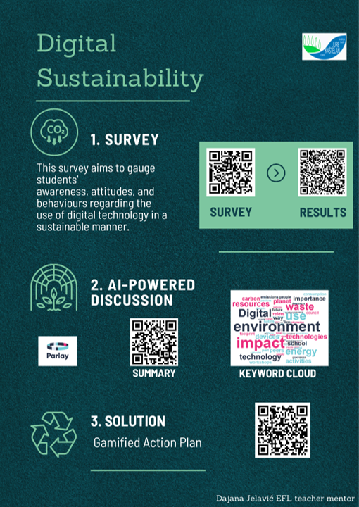

# Tools and Resources

- Google Forms ([Survey](https://forms.gle/zFVhVT4QeHyVLWmB8))  
- Educational [video](https://youtu.be/JJn6pja_l8s) on digital sustainability  
- [Parlay.ai](https://parlayideas.com/) discussion platform  
- [Wordwall](https://wordwall.net/) (for gamified action plan)

# Outcomes

- Students became more aware of their digital habits and their environmental impact  
- Promoted peer-to-peer learning and critical thinking  
- Generated an engaging, student-created toolkit for action  
- Provided teachers with insightful data to guide further activities

# Follow-up Suggestions

- Introduce eco-digital habits challenges across classes  
- Share gamified solutions with the wider school community  
- Connect with other schools for an Erasmus+ collaborative digital sustainability project

Credits:

Writing supported by ChatGPT, an AI developed by OpenAI, with educational guidance by Dajana Jelavić.